**Project Definition Document – PPM Project Read on Nottingham**

**The 2023 Nottingham Year of Stories Website Design**

Introduction

Nowadays, vital communication skills are one of the essential skills that people should have to communicate with other people and integrate into society. A Project Nottingham Year of Stories with Read on Nottingham focuses on improving vital language skills and helps families and young children to improve their life by giving and supporting their vital language skills.

The Read on Nottingham is a program supported by Nottingham City Council and Small Steps Big Changes. Also, this initiative is funded by the National Lottery Community Fund.

This citywide initiative helps children develop reading, writing, speaking, and listening skills. Numerous activities can be beneficial for young people between the ages of 5 and 18. For example, one of the new events is the Miles of Magic event with Bloomsbury Publishing celebrating the 25th anniversary of Harry Potter. This exclusive event can be great for young people to hear how the iconic Harry Potter cover was made and see the Harry Potter characters come to life.

At the current time, there is no existing website as the 2023 Year of Stories, and everything is in the planning stage. As an example, our team decided to use the Yorkshire Festival of Story website (<https://yorkshirefestivalofstory.com>) to acquire new ideas and suggestions.

Aims and Objectives

The main goal our team would like to achieve is to provide maximum support to the younger generation, do our best to improve their vital language skills and help support families and schools through our program. The Nottingham Year of Stories 2023 project aims to support young children, families, and schools to acquire the early literacy skills they need.

One of our aims in this project is to make the website easily navigated by all audiences (families, children, teachers, professionals, and potential donors). Also, in our plans make the website with a variety of functions including:

* A calendar section for bookable and non-bookable activities. For instance, story trails, book signings, theatre, creative writing etc.
* An area where people their stories and storytelling videos, blogs, experiences and so on.
* Useful information on other literacy-related activities in the city.
* Area for financial donators, supporters, and project partners.

Requirements

**Must Haves**

* Inform the user about the Nottingham Year of Stories
* Responsive Design
* Child Friendly Design – Bold text, easily understandable language
* Visually Appealing
* Easy navigation
* Navigation Bar
* Images
* Calendar for activities
* Donation Section

Each of these are important due to the fact that Read On encourages young people to read. The design must not look too formal, it is important to include colour and a design suitable for all ages. The navigation must not be too complex as the user could get easily confused, the site must be easy to use for all ages.

The site will inform the user about the Nottingham Year of Stories and will include activities that they can attend. It will also include a donation section.

Project Management Approach

To ensure we will be able to work as efficiently as possible we had to devise a plan that would outlining how we intend to work. Firstly, we have established a method of communication through the creation of a Microsoft Teams group chat. This will be used for meetings where tasks will be assigned to team members. Also, this area will be used to allow for our team to provide feedback, assistance, and evaluation to our peers. To monitor assigned activities and to track deadlines, we have created a Trello board. This will also allow us to monitor the progress of team members to ensure team members meet deadlines. If a member misses an assigned deadline and / or the quality of the work provided was insufficient, the project manager would firstly communicate with them to determine why this was the case and support them if necessary. However, if they repeatedly fail to meet the required expectations after providing them with three opportunities to improve, we would inform our supervisor so they can take further action. For website development, we will use GitHub which will provide us with a collaboration medium whilst working on our project. This will also be used as a location where we can assess the quality of team members work. Finally, we will ensure regular backups of our work will be performed. This will ensure work is not lost as result of hardware / software issues which could cause the group to miss deadlines.

Team Members & Responsibilities

Our group will consist of four team members. Each team member will perform a wide range of roles whilst developing the website and will be assigned with activities for each task depending on their skillset. However, each member will be responsible for certain specific responsibilities throughout the duration of the project

Aidyn – Will be project manager of the team, also responsible for managing the Trello board and communicator between our team and our supervisor.

Mason – Will be the backup to Aidyn and assistant to the team, also responsible for monitoring the Teams group chat by assigning and scheduling group meetings.

Sam – Will be backup to Mason and will be responsible for quality control and testing throughout the development stages throughout the project.

Yat - Will assist Aidyn and Mason in managing and monitoring the Trello, Teams chat and other communication mediums throughout the project

Abdul - Will assist Sam with performing quality control and testing throughout the development stages of the project.

Resources Required

This section of the report will outline the information we need obtain as well as the hardware and software we need to develop the project with as well as how we will obtain each resource

Sources Of Information

* Client requirements – These will be obtained through the brief we have been given and more specific needs will be obtained through regular meetings with the client
* Software Guidance – These will be obtained through the web I.e. NTU Content related to IAD, and through websites such as W3Schols which will aid us in the development of the websites.
* External Feedback – These will be obtained by consulting with the client and supervisor at regular intervals to see where aspects can be improved
* Similar Websites – These will be obtained by searching the web to look for existing websites based on the area we are developing in which will assist us during the design phase of the project

Hardware / Software Requirements

* Visual Studio Code – to implement our code
* Web Server for Chrome – to test our website using web server
* Trello – to plan our steps

Risk Assessment

Likelihood: 1- Highest 5-Lowest

1 - One risk to the project is one of the team members becoming ill, whether this be contracting covid or another illness. This is still an issue that we must be aware of as if this were to happen, the team member may not be able to complete their work to the full extent. This is an external factor that cannot be directly minimised other than the usual covid preventions such as wearing a mask in public. This may have a large impact on the project. This would have a large impact if one of the team members is unable to work.

2 - Another risk is a team members internet connection not working. This could be due to work being done in the area. The risk of this cannot be directly minimised. If this were to happen it would be best for the team member to work elsewhere in an area with internet connection such as the university library. This would have a smaller impact on the project as the internet problems may only be temporary and the team member would be able to work elsewhere as suggested.

3 - A further risk would be hardware failures from the team, such as a computer breaking. This would leave the team member unable to complete work unless they could find a backup. The harm could be reduced by backing up files onto another computer or safeguarding against viruses. This may have a large impact on the project if a team member is not able to find an alternative computer to work on.

4 – Another risk is lack of communication. This could happen for many reasons but if this were to happen it could interfere with the timeframe of the assignment due to each team member’s individual work. If the team cannot communicate effectively then the project will not be at a high standard. This would have a large impact if it happened but is unlikely.

5 - One of the risks of our project is members repeatedly missing their individual work deadlines. If this continued to happen then this would have an overall effect on the project, potentially slowing progress and effecting the outcome. This could be minimised through effective communication and regular updates from team members. This would also have a large impact on the team as the overall progress would be slowed, although this is unlikely to happen.

Professional Considerations

BCS Code of Conduct sets the standards of behavior we expect and the work values that help maintain a good reputation. Our values - creativity, openness, Public Interest, Professional Competence and Integrity responsibility and entrepreneurship. We strictly adhere to the high standards of BCS and Duty to the Profession. The BCS Code of Conduct guides us in putting our values and commitments into practice into practice - throughout our team and in everything we do. Where responsible The NTU Plagiarism Code of Conduct guides us when responsible behavior and ethics are important to our decisions. Our Code of Conduct will guide us when responsible behavior and ethics are important to our decisions. The goal of Stories Website Design is to satisfy people's desire for knowledge and to help children develop reading, writing, speaking and listening skills and improve their quality of life.

Project Plan

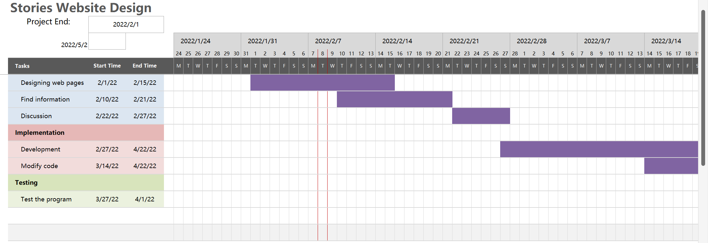

References

National Literacy Trust. (n.d.). Read On Nottingham. [online] Available at: https://literacytrust.org.uk/communities/nottingham/ [Accessed 8 Feb. 2022].

‌Anon, 2021. Festival info. Yorkshire Festival of Story. Available at:https://yorkshirefestivalofstory.com/festival-info [Accessed February 8, 2022].